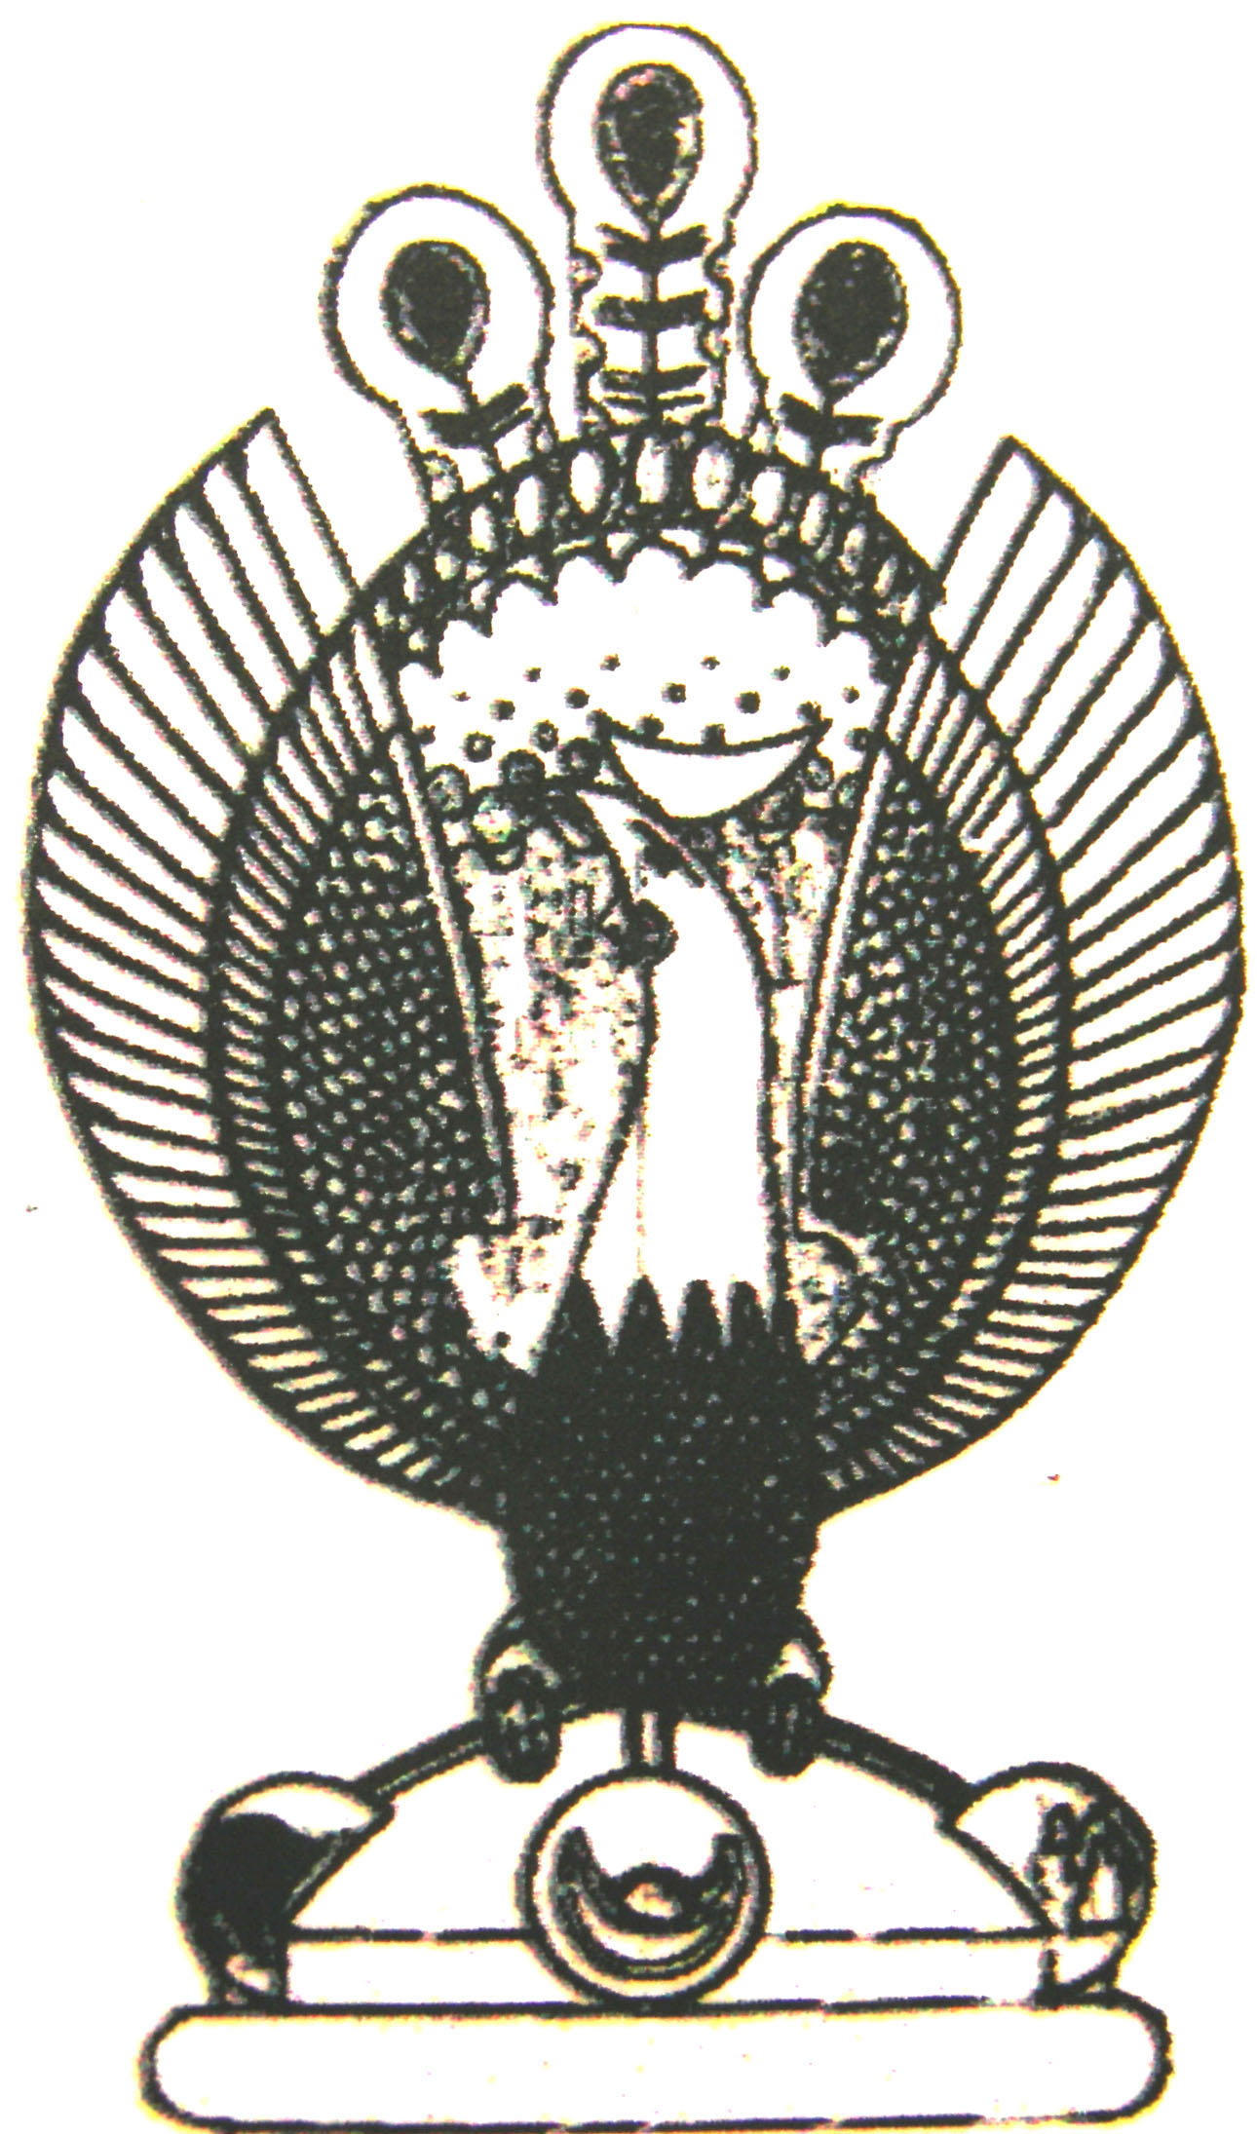

THE HERITAGE
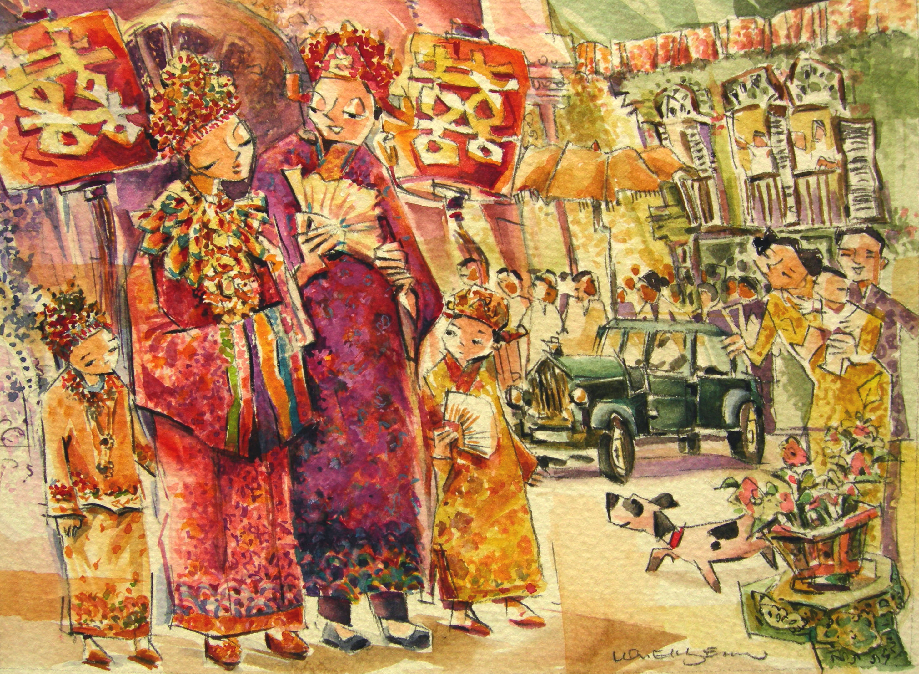
Mounting the horse
Before noon, a procession leaves the Groom’s house to the bride’s house. This is called ‘mounting the horse’.

